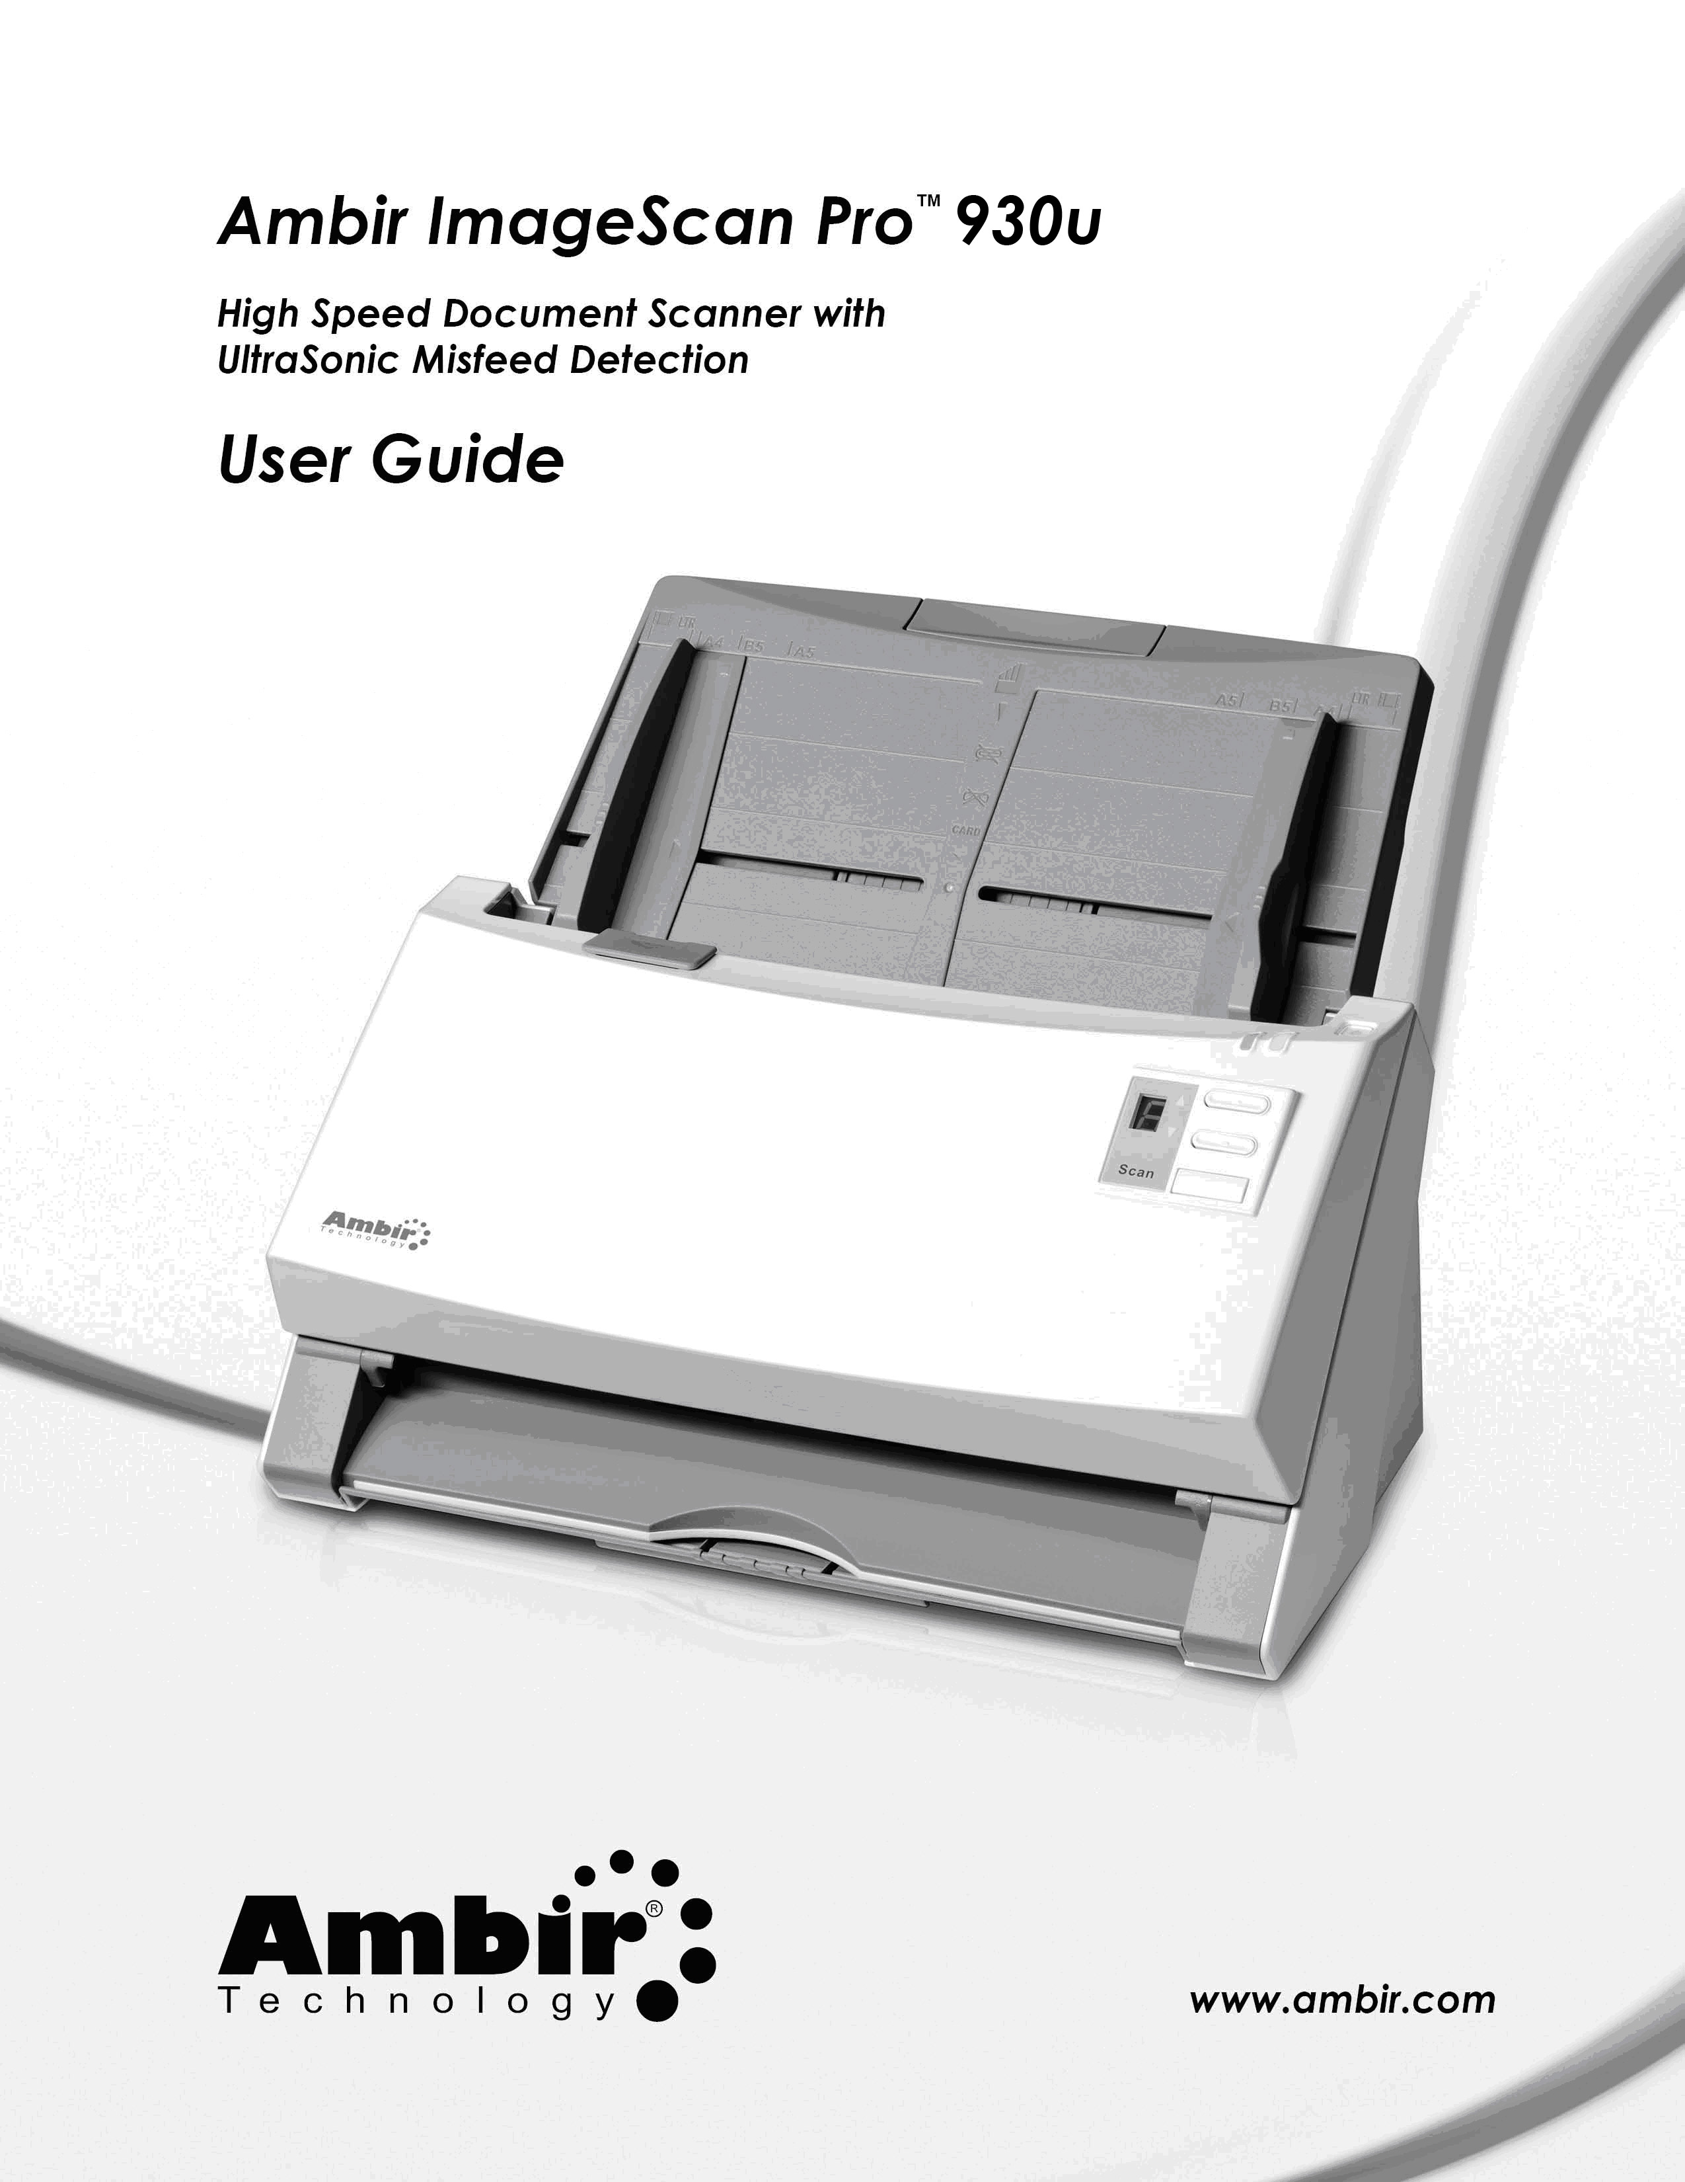

Trademarks
©2011 Ambir Technology, Inc. All rights are reserved.

All trademarks and brand names mentioned in this publication are property of their respective owners.

Liability
While all efforts have been made to ensure the accuracy of all contents in this manual, we assume no liability for errors or omissions or by statements of any kind in this manual, whether such errors are omissions or statements resulting from negligence, accidents, or any other cause. The contents of this manual are subject to change without notice. We will not bear any legal liability if users fail to follow the operation instructions in this manual.

Copyright
The scanning of certain documents, e.g. checks, bank notes, I.D. cards, government bonds, or public documents, may be prohibited by law and/or subject to criminal prosecution. Please be responsible and respectful of intellectual property and copyright laws when scanning books, magazines, journals and other materials.

Environmental Information
Ambir Technology is committed to the environment. This product is designed and produced to achieve sustainable environmental improvement. We strive to produce products in compliance with global environmental standards. Please consult your local authorities for proper disposal. Our product packaging is recyclable.

Screen Examples in This Manual
The screen shots in this guide were made with Windows XP. If you are using Windows 7, Vista or 2000, your screen may look somewhat different but functionality is not affected.

Table of Contents
Introduction 4
How to Use This Guide 4
Guide Conventions 5
A Note about Icons 5
Safety Precautions 5
Minimum System Requirements 6
Box Contents 7
The Scanner Features 8
LED Indicator 10
Ultrasonic Sensor 11
Chapter I. Installing the Scanner 12
Software Installation Requirements 12
Hardware Requirements 12
Installing and Setting up the Scanner 13
Step 1. Install the Paper Chute 14
Step 2. Connecting the Scanner to Your Computer 15
Step 3. Installing the Software 16
Step 4. Testing the Scanner 17
Installing Additional Software 18
Chapter II. Scanning 19
Preparing Documents 20
Checking Document Conditions 20
Loosening Documents 21
Placing Documents 21
Placing Business Cards 23
Placing Plastic Cards 24
Scanning Documents 25
Scanning via TWAIN Interface 25
Scanning from the Scanner’s Front Panel 27
Scanning from the On-screen AmbirScan ADF Execute Menu 29
Chapter III. Care and Maintenance 31
Cleaning the Scanner 31
Cleaning Materials 31
Cleaning the ADF 32
Replacing Consumables 34
Replacing the Pad Module 34
Replacing the Feed Roller 35
Calibrating the Scanner 39
Power Save 40
Chapter IV. Troubleshooting 41
Scanner Connection 41
Clearing Paper Jams 42
Appendix A: Specifications 43
Appendix B: Customer Service and Warranty 44

Introduction
Thank you for purchasing an Ambir scanner. We have designed this product to provide you with an effective tool to capture, manage, and archive documents of many types. We encourage you to read this important User Guide carefully.

How to Use This Guide
This User Guide provides instructions and illustrations on how to install and operate your scanner. This guide assumes the user is familiar with Microsoft Windows 2000 Professional / XP / Vista / 7.
The Introduction section of this manual describes the box contents and minimum system requirements to use this scanner. Before you install your scanner, check the box contents to make sure all parts are included. If any items are damaged or missing, please contact the point of purchase.
Chapter I describes how to install scanner’s software and connect the scanner to your computer. Note: The scanner connects to your computer through the Universal Serial Bus (USB). If your computer does not support USB technology, you will need to purchase a USB interface card to add USB capabilities to your computer, or buy and install USB connectors if your motherboard has USB capabilities. This guide assumes that your computer is USB-ready and has a free USB port.
Chapter II describes how to use your scanner.
Chapter III describes how to maintain and clean your scanner.
Chapter IV contains technical support information that can help you solve simple problems.
Appendix A contains the specifications of the scanner you purchased.
Appendix B contains our customer service, the limited warranty agreement and FCC statement concerning the product.

Guide Conventions
Bold — Represents commands or contents on your computer screen.
ALL CAPS — Important note or first use of an important term in a chapter.
Italic — Represents buttons on your scanner OR important notes.

A Note about Icons
This guide uses the following icons to point out information that deserves special attention.
Warning | A procedure that must be followed carefully to prevent injury or accidents.
Attention | Instructions that are important to remember and may prevent mistakes.
Information | Optional tips for your reference.

Safety Precautions
Warning | Before using this device, please read the following important information to eliminate or reduce any possibility of causing damage and personal injury.
1. The product is for indoor use in dry locations. Condensation may occur inside this device and cause malfunction if the following conditions are met:
  - when this device is moved directly from a cold to a warm location;
  - after a cold room is heated;
  - when this device is placed in a damp room.
To avoid condensation:
i. Seal this device in a plastic bag to allow it to adapt to room conditions.
ii. Wait for 1-2 hours before removing this device from the bag.
2. Use only the AC adapter and USB cable provided with the scanner. Use of other AC adapter and cables may lead to malfunction.
3. Keep the space around the AC adapter clear in case you need to quickly unplug the AC adapter during an emergency.
4. Damaged wire could cause fire or electrical shock. Keep the power cord straight and avoid placement where it could lie twisted or bent.
5. Unplug this device if you don’t need to use it for an extended period of time to avoid any risks of causing a fire.
6. Do not attempt to disassemble the scanner. There is danger of electric shock. Opening your scanner will void your warranty.
7. Be sure not to bump or knock the scanner glass as it is fragile and could break.
8. Do not subject the scanner to excessive vibration. It may damage the internal components.

Minimum System Requirements
- PC with Intel Pentium® IV 2.0 GHz processor or compatible. (Pentium IV 3.0 Ghz recommended)
- 1 GB RAM
- Available USB port. (USB 2.0 recommended)
- CD-ROM Drive or DVD-ROM Drive
- 800 MB Free Hard Disk Space (1GB or larger recommended)
- High color graphic card (VGA or higher)
- Operating System: Windows XP (Compatible), Windows 2000, Windows Vista, Windows 7

Information | Systems with Pentium® IV 3.0 GHz or higher processor (or its compatible), 1 GB RAM and 1GB free hard disk space are recommended for optimal performance.

Box Contents
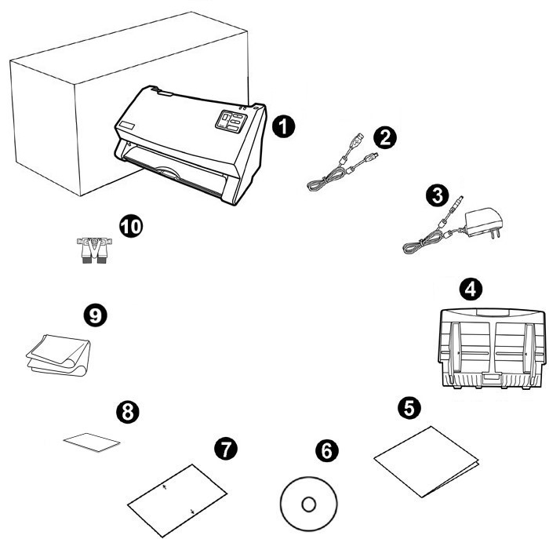

1. Scanner
2. USB Cable
3. AC Adapter
4. Paper Chute (Automatic Document Feeder or ADF)
5. Quick Guide
6. Setup/Application CD-ROM
- Calibration Sheet
- Memo Label
- Cleansing Cloth
- Pad Module

Scanner Features
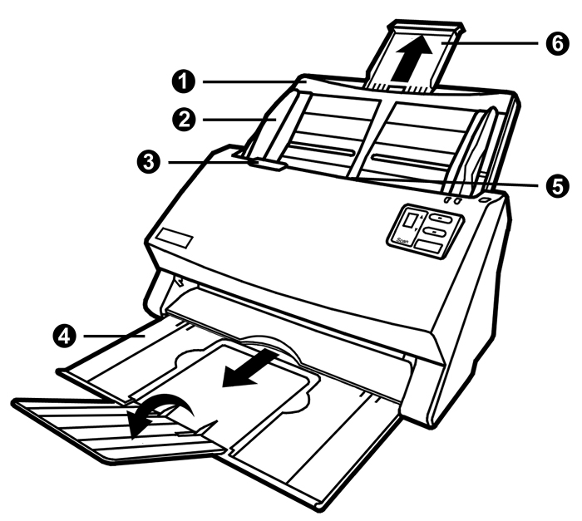
- PAPER CHUTE—Helps keep the paper in place. Install the paper chute before using the scanner.
- PAPER WIDTH SLIDER—Adjusts the paper width slider for the paper size you are using.
- COVER OPEN LEVER—Opens the cover of the Automatic Document Feeder (ADF). Pull it to open the ADF cover when you need to clear paper jam or clean the scanner.
- STACKER—Keeps the paper in place. Extend it in case of longer paper.
- ADF (AUTOMATIC DOCUMENT FEEDER)—Automatically feeds a stack of documents for scanning.
- PAPER CHUTE EXTENSION—Extends to hold longer paper.
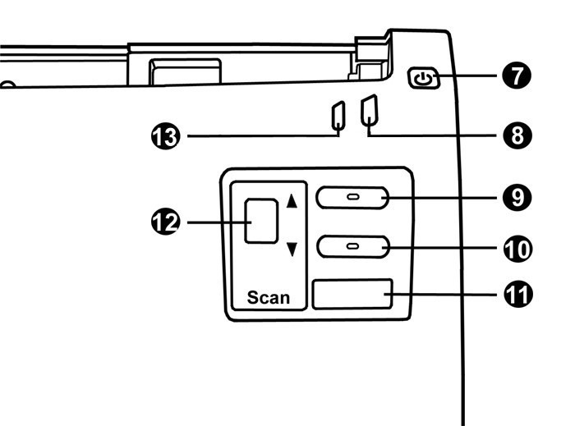
- POWER SAVING BUTTON—Press and hold about one half-second to enter the standby mode (sleep mode). You may press this button again to wake up the scanner from power saving.
- POWER / POWER SAVING LED—Indicates the scanner status.
- UP BUTTON—Press to move forward the scanning task number indicated in the function number display.
- DOWN BUTTON—Press to move backward the scanning task number indicated in the function number display.
- SCAN BUTTON—Press to perform a predefined scanning task selected by the up or down button.
- FUNCTION NUMBER DISPLAY—Indicates the number of the predefined scanning task selected by the up or down button.
- WARNING LED—Indicates the scanner error status.
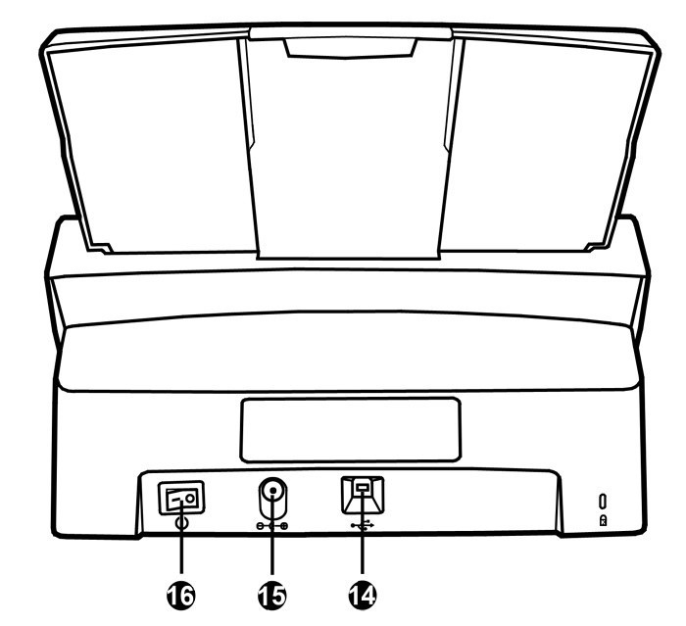
- USB PORT—Connects the scanner to a USB port on your computer by the included USB cable.
- POWER RECEPTOR—Connects the scanner to a standard AC power outlet by the included AC adapter.
- POWER SWITCH—Use this to turn the scanner ON or OFF.

LED Indicator

The Power/Power Saving LED and Warning LED indicate different scanner status.

Warning LED Light | Power / Power Saving LED Light | Status
Off | White | The scanner is turned on, ready to scan images.
Off | Orange | The scanner is in standby mode (sleep mode). It will enter this mode if it is idle for 10 minutes.
Red | Blinking White | The ADF cover is opened.
Blinking Red | White | Paper jam.
Blinking Red | Off | An internal component of the scanner may have malfunctioned.
Off | Off | The scanner is off, either because the power is not turned on, or because the AC adapter is not properly plugged into an AC power outlet.

Ultrasonic Sensor

When scanning a stack of documents using the ADF, the Ultrasonic Sensor detects and prevents paper jams by checking paper overlap. If the Sensor detects 2 or more pages stuck together when being fed through the ADF, it halts scanning and triggers a message on your computer screen, letting you separate the sheets and continue scanning.
To keep the Ultrasonic Sensor working properly, clean it lightly with a dry cloth.
Information | This function may or may not be available depending on the scanner model you purchased.

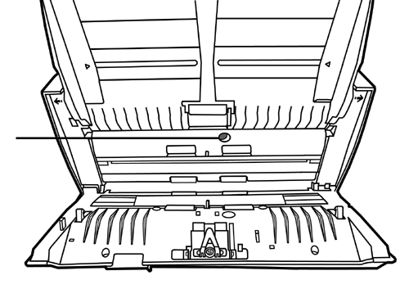
Ultrasonic Sensor

Chapter I.

Installing the Scanner
Before installing your scanner, please verify that you have all of the proper components. A list of the package contents is provided in the “Box Contents” section on Page 4 of this guide.

Software Installation Requirements
Your scanner comes with the following software included:
- AmbirScan ADF
- OCR software (ABBYY FineReader 9.0 Sprint)
- Document management software (NewSoft Presto! PageManager 9)
- Contact management software (NewSoft Presto! BizCard)
- Scanner driver
All of these software applications use approximately 400 megabytes of hard disk space after they are installed into your computer. To ensure ample room for the installation, as well as for scanning and saving images, a minimum of 1 GB of hard disk space is recommended.
This USB scanner can only operate under the Microsoft Windows XP / Vista / or Windows 7 operating systems.

Hardware Requirements
This scanner connects to your computer through the Universal Serial Bus (USB) which supports HOT PLUG AND PLAY. To determine whether your computer is USB-capable, you must check the rear of your PC to locate a USB jack that looks like the picture below. Some computers provide USB jacks in the front. If you are having trouble in locating a USB port on your computer, please refer to the hardware manual that came with your computer.

Upon examination, you should find one or two rectangular USB ports, which usually appear as shown below.

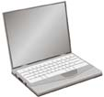
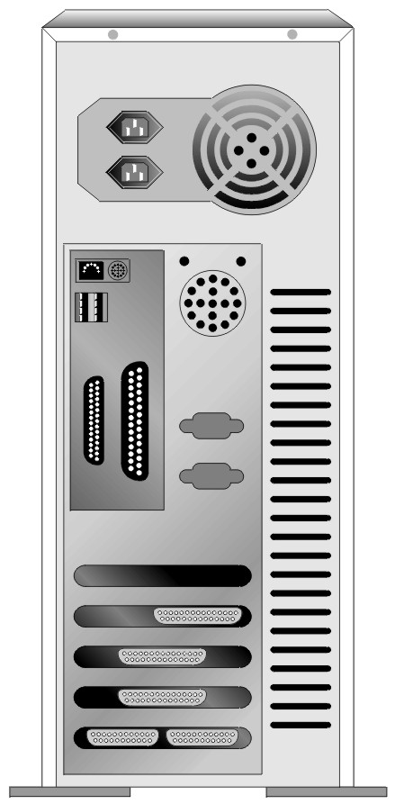
USB Connector(s)
If you don’t find such USB ports on your computer, then you need to purchase a certified USB interface card to add USB capabilities to your computer.

Installing and Setting up the Scanner
Please follow the step-by-step procedures described below to install the Ambir ImageScan Pro™ 940u scanner.

Attention | Choose the right location first!  - Always place your scanner on a level, smooth and strong surface before proceeding with scanner setup or any scanning task.  A tilted or uneven surface may cause paper-feeding errors, scanner damage or personal injury.  - Avoid using the scanner in a dusty environment. Dust particles and other foreign objects may damage the unit.

Step 1. Install the Paper Chute
  - Open the ADF cover by pulling the lever, and get the paper chute ready.
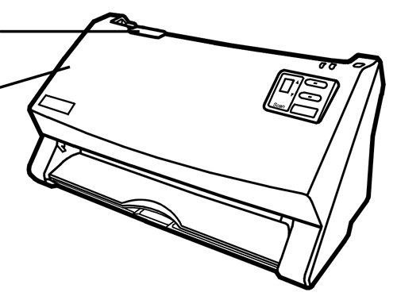
Cover open lever
ADF cover
  - Install the paper chute by aligning and inserting the tabs of the paper chute into their slots on the scanner.

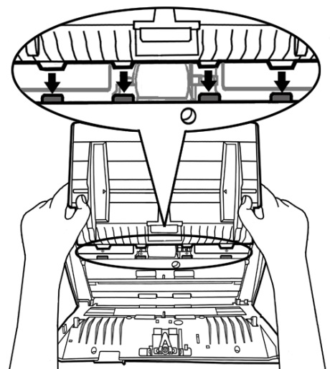

3. Close the ADF cover by pushing it back down until it snaps back into place.
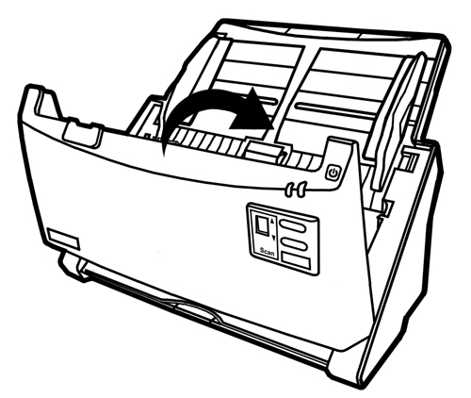

Step 2. Connecting the Scanner to Your Computer

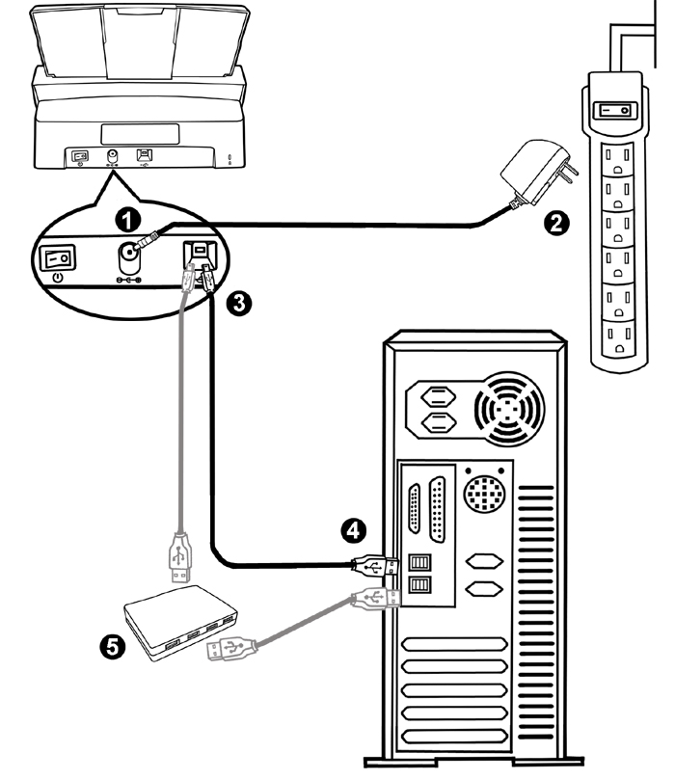
Attention | Please make sure the scanner is turned OFF before you plug or unplug the scanner power adapter.
1. Plug the AC adapter into the scanner’s power receptor .
2. Plug the other end of the AC adapter into a standard AC power outlet.
3. Plug the square end of the included USB cable to the USB port at the rear of the scanner.
4. Plug the rectangular end of the USB cable to an available USB port on your computer.
- If you plan to connect your scanner to a USB hub, make sure that the hub is connected to the USB port in your computer. Next, connect the scanner to the USB hub.

Step 3. Installing the Software
- Switch on the scanner power from the rear of the scanner.
- If the USB components on your computer are functioning correctly, they will automatically detect the scanner causing the Add New Hardware Wizard or Found New Hardware Wizard to be launched.

Information | If your computer is off when the scanner is connected, the “Add New Hardware Wizard” message will not be displayed until the computer is on and Windows starts.
3. For Windows XP:
a. Insert the Setup/Application CD-ROM included with your scanner into your CD-ROM drive.
b. Select Install the software automatically recommended and click the Next button.
- Click the Next button in the window that appears. Afterwards, please skip to step 7.
4. For Windows Vista:
  - Select “Locate and install driver software (recommended)” when the “Found New Hardware” window is displayed.
  - Click on the Continue button when the “User Account Control” dialog pops up.
  - Insert the Setup/Application CD-ROM included with your scanner into your CD-ROM drive when the system prompts you “Insert the disc that came with your USB Scanner”, and click on the Next button. Afterwards, please skip to step 8.
- For Windows 7:
When the Setup/Application CD is for one scanner model
a. Insert the Setup/Application CD-ROM, included with your scanner, into your CD-ROM drive. Click Run install.exe in the AutoPlay window.
b. Click on the Yes button if the User Account Control dialog pops up. If the pop-up wizard window appears click Next, and click Install this driver software anyway in the Windows Security window then click Finish in the wizard window. Afterwards, please skip to procedure 9.
7. During the process of the installation, a message “Windows can’t verify the publisher of this driver software” might appear. You may safely ignore it, and click on Install this driver software anyway to continue the installation.
8. When the system completes the installation, click the Finish button.
9. Follow the on-screen instructions to install all software that your new scanner requires.
- After the software is installed, close all open applications and click the Finish button to restart your computer.

Information | If the scanner installation is not started and displayed automatically on the screen, click Start, select Run and type in D:\Install (where D: is the drive letter assigned to the CD-ROM drive of your computer.)

Step 4. Testing the Scanner
The following describes how you can check if the scanner is properly functioning with your computer and the scanning software by performing your first scan with our bundled application NewSoft Presto! PageManager 9. Before testing your scanner, double-check to make sure that all cable connections are securely fastened.

To test ADF scanning:
- Load a document headfirst and face down into the ADF with the text side facing the paper chute. (For detailed instructions on loading paper into the ADF, please refer to the “Preparing Documents” section of this guide.)
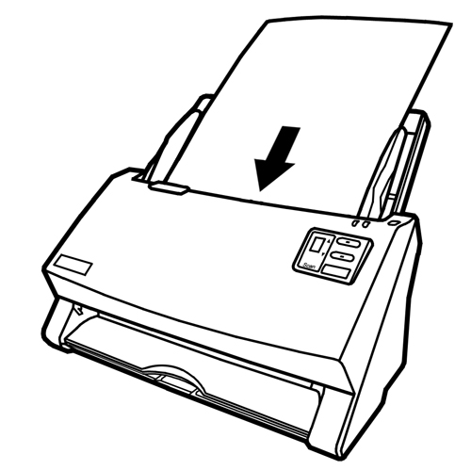
2. Click the Windows Start button to launch NewSoft Presto! PageManager 9.
3. (If you have only one scanner connected with your computer, please skip to Step 4.)
If you have more than one scanner or other imaging device installed on your computer: Click Select Source from the File menu of Presto! PageManager 9 and then choose the Ambir ImageScan Pro ™ 940u scanner as the default scanning source.
4. Within Presto! PageManager 9, click Tools > Scan Settings > uncheck “Suppress TWAIN User Interface” > OK. Click File > Acquire Image Data.
5. Select ADF (Front Side) as the Scan Type within the TWAIN window.
6. Click the Scan button.
7. The document in the ADF paper chute should be now loaded into the ADF and scanned. After this process, you should see a scanned image of the document on your screen.
8. Click Exit to exit the TWAIN window.

Installing Additional Software
Your scanner is TWAIN-compliant and functions with virtually all available TWAIN compatible software. If you purchase additional software to be used with your scanner, please make sure that it conforms to the TWAIN standard.

Chapter II. Scanning
The AmbirScan ADF program seamlessly integrates the operation of your scanner with your computer and other peripherals. AmbirScan ADF provides a quick and convenient way to perform various scanning functions. With AmbirScan ADF, you don't need to adjust settings every time you scan. Simply press any button on the scanner's front panel or click any scanning menu item of AmbirScan ADF on the screen. The scanner starts to scan your paper documents and transfer them to your assigned destination. The destination can be a printer, your E-mail program, files on your disk drives, an image-editing program, etc.
Since all documents or images (whether text or pictures) acquired from the scanner are treated by your computer as images, most scanning will be done from an image-editing program where you can view, edit, save and output the scanned images. A document management program to scan, share and organize images, NewSoft Presto! PageManager 9 has been bundled for your scanner on the included Setup/Application CD-ROM. It will allow you to alter and correct any scanned images by using a variety of filters, tools and effects.
Need to scan text documents and edit them in a word processor? This is the role of Optical Character Recognition (OCR) software. OCR software converts the image files that are created when scanning text documents into text files that can be viewed, edited and saved by word processors. An OCR program, ABBYY Fine Reader Sprint 9 has also been bundled on the included Setup/Application CD-ROM. In order to use the scanner in this way, install the included OCR software.
Please refer to the online help of each program to guide you through any questions you may have while scanning within that program.
This chapter describes three important steps of scanner operations. Read them thoroughly and follow the instructions to ensure correct use and optimal scanner performance.
Step 1. Preparing Documents
Step 2. Placing Business Cards, Placing Plastic Cards
Step 3. Scanning Documents

Preparing Documents
Proper document preparation prior to the scan can prevent paper feed errors and damages to the scanner.

Checking Document Conditions
Make sure the size and ream weight of your documents are acceptable by the scanner. Refer to “Appendix A: Specifications” of this guide for more information.
Scanning multiple documents in a batch from the ADF can increase your work efficiency and make large scanning tasks easier. The ADF of this scanner accepts a variety of paper and stationery, such as:
  - Normal paper whose size and ream weight meet the requirements stated in “Appendix A: Specifications” of this guide.
  - Notched paper
  - Coated paper (such as brochures)

Attention | To prevent paper feeding errors and damages to the ADF unit, strictly follow the instructions below:  - Remove all small objects e.g., paper clips, pins, staples or any other fasteners attached before loading the paper into the ADF.  - Make sure the paper is completely flat with no creased or curled corners.  - Avoid scanning documents with pencil lead and newspaper clippings as they will make the ADF exposure glass and the inner ADF dirty. If you have to scan such paper, clean the scanner frequently (refer to Maintenance section of this guide for more information).  - The paper for each batch scanned by ADF can be of the same or different weights. However, make sure the length of each scan batch is the same.
However, don’t use the ADF to scan any of the following documents:
  - Paper lighter than 14 lb. (50 g/m²) or heavier than 28 lb. (105 g/m²)
  - Paper with clips or staples attached
  - Paper with inconsistent thickness, e.g., envelopes
  - Paper with wrinkles, curls, folds, or tears
  - Paper with an odd (non-rectangular) shape
  - Tracing paper
  - Carbon paper, pressure sensitive paper, carbonless paper
  - Items other than paper, e.g., cloth, metal foil.

Attention | - DO NOT use the ADF to scan photographs or valuable document originals; wrinkles or other damages can result if paper feeds improperly.  - DO NOT place paper with wet ink or correction fluid into the ADF. Wait enough time to allow to dry before scanning.

Loosening Documents
Before loading a stack of documents into the ADF, loosen them as follows:
1. Fan the documents so that no two pages are sticking together.
2. Hold the documents upside down with both hands, and then gently push them onto a flat surface to align the edges of all documents.
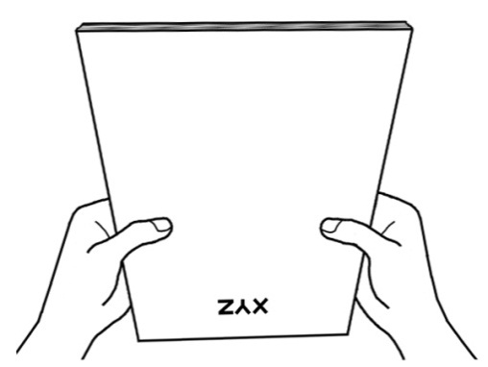
This will allow documents being fed into the ADF one at a time and prevent paper-feeding errors.

Placing Documents
1. Load the documents, headfirst and face down, toward the center of the ADF paper chute and all the way into the ADF until touching the bottom.
For single-sided scans, load the documents face down so that the side to be scanned faces towards the paper chute.
For double-sided scans, load the desired page order of documents face down so that the side to be scanned faces towards the paper chute. If you wish to scan both sides of a single page, the page need only pass through the ADF once. Set the scan type to “Duplex” in the AmbirScan ADF interface.
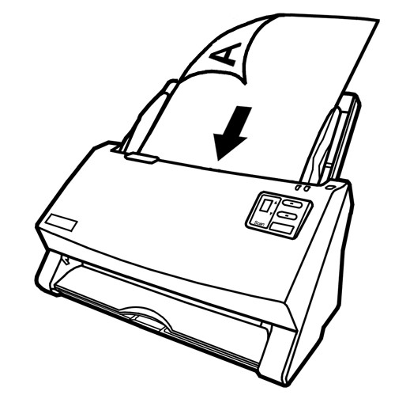
- If you need to scan longer documents, pull out the paper chute extension and stacker to provide further support for the documents.

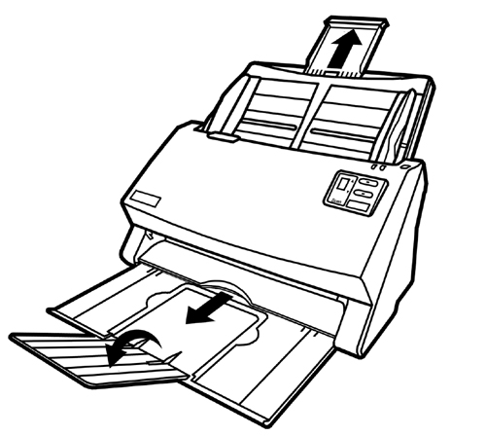

- Adjust the paper width slider for the paper size you are using. The paper width slider should be gently touching both sides of the documents.
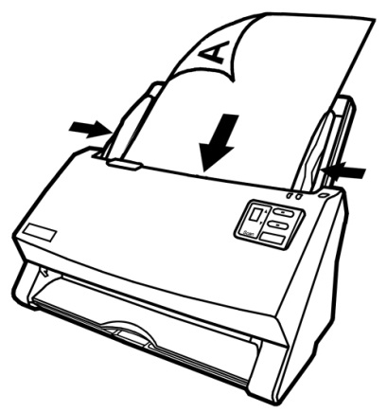

Attention | - DO NOT load more than 100 sheets of paper (70 g/m², 18 lb.) to the ADF.  - Paper scanned from the ADF must be a minimum of 5.08 x 5.08 cm (2” x 2”, W x L).  - Make sure there are no gaps between the document stack and the paper-width slider; otherwise, the scanned images can be skewed.  - Although the documents should be loaded firmly in place ensuring optimum scanning accuracy, they should never be wedged in so tightly that the process of feeding them through the scanner is strained.  - Do not load additional paper into the ADF while the unit is feeding and scanning.

Placing Business Cards
- Horizontally load the business cards, headfirst and face down, toward the center of the ADF and all the way into the ADF until touching the bottom.
For single-sided scans, load the business cards face down.
For double-sided scans, load the business cards in desired order. Use the desktop scanning interface to set mode to “duplex.” As long as the scan type is set to “duplex”, each card will need to pass through the scanner only once.
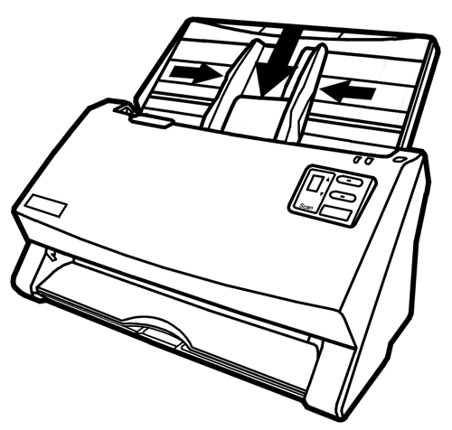
- Adjust the paper width slider to the business card width. The paper width slider should be gently touching both sides of the business cards.

Attention | - Make sure the business cards you wish to scan are horizontally loaded into the ADF.  - Don’t load more than 30 business cards in one batch.

Placing Plastic Cards
The Ambir ImageScan Pro 940u is equipped to scan plastic cards. Plastic cards can be embossed credit cards, driver licenses, ID cards, insurance cards, Medicare cards or any membership cards. Make sure to load the embossed face of the embossed card top first, face down into the scanner.
- Horizontally load the plastic card, top first and face down, toward the center of the ADF.
For single-sided scans, load the card face down.
For double-sided scans, load the card in desired order.
- Adjust the paper width slider to the card width. The paper width slider should be gently touching both sides of the card.

Attention | - Make sure the plastic cards you wish to scan are horizontally loaded into the ADF.  - Maximum thickness of each plastic card is 1.2 mm.  - Load up to five (5) plastic cards per batch.

Scanning Documents
There are three different ways to operate the scanner when scanning documents:
1. By acquiring images from the scanner into a TWAIN-compliant application through our TWAIN software interface.
2. By scanning from the buttons on the scanner front panel.
3. By scanning from AmbirScan ADF Execute menu on the screen.
The TWAIN interface and AmbirScan ADF software are automatically installed to your system along with the scanner driver.

Attention | Before you start scanning, check the following:  - Your computer and scanner are both turned on.  - Theicon appears on the Windows system tray.  - Paper is properly loaded into the ADF.

Scanning via TWAIN Interface
The TWAIN program is a very important piece of software that comes with your scanner. This program acts as an interface between the scanner hardware and the image-editing software you are using to view and edit images. The TWAIN program allows you to adjust a number of settings to define the quality of the scanned image.
The following describes how you may use our bundled application (NewSoft Presto! PageManager 9) to scan via TWAIN interface. When you get familiar with the scanning, you may alternatively use other TWAIN compatible scanning program or image-editing application to do your scanning projects.

Scan within NewSoft Presto! PageManager 9:
- Click the Windows Start button to launch Presto! PageManager 9.
Attention | If you have more than one scanner or other imaging devices installed on your computer, you need to set this scanner as the default scanning source before you before you acquire image data within PageManager 9.  - From the File menu of PageManager 9, click Select Source.  - In the window that opens, choose Ambir ImageScan Pro 940u and then click the OK button to set this scanner as the default scanning source.

2. Within Presto! PageManager 9, click File > Scan Settings > uncheck “Suppress TWAIN User Interface” > OK. Click File > Acquire Image Data.
- In the TWAIN window that opens, select ADF (Front Side) as the Scan Type if you want to scan single-sided documents, or select ADF (Duplex) to scan double-sided documents.

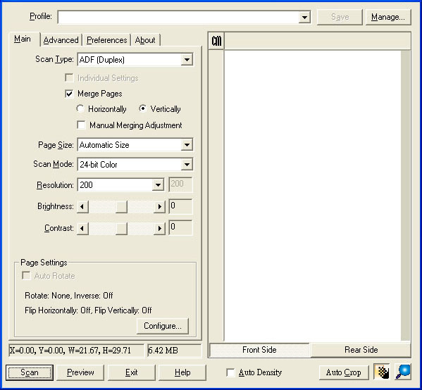

- Adjust the scanning settings. For ADF (Duplex) scan, you can tailor settings individually for front and rear sides of the documents. Click the Front Side button to adjust the scanning settings of the document's front side and then click Rear Side button to adjust the scanning settings of document's rear side.
You can enable the function of Merge Pages only when you select ADF (Duplex) as Scan type and Automatic Size as Page Size to output the scan images of both front and rear sides in one image. Enable the Merge Pages function to join front and rear images. You can select Horizontally to generate both front and rear image data horizontally in a joined image (the rear image will be placed at the right side next to the front image), or make the selection of Vertically to generate both front and rear image data vertically in a joined image (the rear image will be placed below the front image).
5. Begin the scanning process by loading one page of the document and click the Preview button. The scanned image should appear in the Preview Window. To define the margins and to crop out (remove) sections of the image you don’t want scanned, use the mouse to click and drag the corners or sides of the scan area borders. Adjust the scan settings and click Preview again if the preview image doesn’t satisfy your needs.
- Load all pages of the document and click the Scan button.
- When the scan finishes, click the Exit button to close the TWAIN window. The scanned images are displayed in Presto! PageManager 9, and you may perform any image editing tasks.
Click the Help button within the TWAIN window for more information about the settings.

Scanning from the Scanner’s Front Panel
Using the Ambir ImageScan Pro™ 940u front buttons to control scanning is very easy and convenient once you set the front panel controls up. The number of scanning tasks displayed on the scanner’s front panel is configured through AmbirScan ADF. AmbirScan ADF offers you quick access to the most frequently-used scanning functions. These are especially useful when you need to repeatedly scan with the same settings and send images to the same destination. Before performing your first scan using the scanner’s front buttons, you should configure the button settings to your needs and preferences first.

Scan from the Scanner Buttons
- Place the document or images onto the scanner. (Refer to the Loading Documents section of this User Guide for more information on how to place paper into the ADF properly.)
- Check current button settings by viewing AmbirScan ADF's “Button Configuration” window. In this window are found the default settings for the buttons, which you can use as is, or you can change. Also provided with the scanner is a sticker with factory defaults printed and blank space to record your own button configuration. If needed, you may modify settings to meet your current needs. (Refer to “View Button Settings” and “Configure Button Settings” below for more information.)
- Press the UP or DOWN button to select the desired task number 1-9.
- Press the Scan button.
The scanner starts to scan immediately and carry out the corresponding action according to settings you have set up in the Button Configuration window.
Attention | Place only text documents for OCR purposes. Do not scan a photo using the OCR button.

Configure Button Settings
Within the “Button Configuration” window, you can find a row of icons running through the left side of the window. Each icon represents a scanning task, and the number underneath corresponds to the function number displayed on the scanner front panel. Nine (9) frequently-used scanning tasks are pre-configured for your convenience to start scanning immediately. You may, however, customize the settings of every nine tasks to best meet your needs and preferences. Follow the steps described below:
- Do one of the following to open the Button Configuration window:
- Double-click the icon in the Windows system tray.
- Right-click the icon in the Windows system tray, and then choose Button Configuration… in the pop-up menu that opens.
- Select a task number by clicking on the icon.
- Select the desired function from the drop-down list of Button Template and adjust button settings.

Information | As an option, you may wish to write down the customized button number settings on the included memo label and place the label the scanner.
Click the Help button within the Button Configuration window for more information about the settings.

View Button Settings
There are three ways to view the button settings:
- Double-click the icon in the Windows system tray.
- Right-click the icon in the Windows system tray, and then choose Button Configuration… in the pop-up menu that opens.
- View your memo if you write down the customized button number settings on the memo label.

Scanning from the On-screen AmbirScan ADF Execute Menu
You may also use AmbirScan ADF's on-screen “Execute” menu to perform the same scanning tasks. The AmbirScan ADF program provides a quick and convenient way to perform various scanning functions. Follow the steps described below:
- Place the document or images onto the scanner.

- Check current button settings by viewing the memo label or the Button Configuration window. If needed, you may also modify settings to meet your current needs.
- Right-click the icon in the Windows system tray, and then choose Button Configuration… in the pop-up menu that opens.

- Click the desired button function item in the pop-up menu.

The scanner starts to scan immediately and carry out the corresponding action according to settings you have set up in the Button Configuration window.

Chapter III.

Care and Maintenance
Your scanner is designed to be maintenance-free. However, timely care and maintenance can keep your scanner working smoothly.

Cleaning the Scanner
Paper powder, dust, ink and toner from paper being scanned may make the inner ADF dirty, which leads to poor image quality or document-feeding errors. How often to clean your scanner depends on the type of paper and number of pages being scanned over time. In business environments, monthly maintenance may be appropriate. For more information, visit http://www.ambir.com/care
Perform the following procedures to clean the scanner surface and the ADF unit. Gently wipe locations described below. Do not rub too hard.
Warning | - Before cleaning the scanner, turn off the scanner and disconnect the scanner’s power cable and USB cable, and then wait a few minutes for the glass and/or the inner ADF to cool to room temperature.  - Wash your hands with soap and water after cleaning the scanner.

Cleaning Materials
Have the following cleaning materials ready to clean the scanner:
  - soft, dry, lint-free cloth (or a cotton swab)
  - non-abrasive cleaner—Isopropyl alcohol (95%). DO NOT use water.
  - Alternatively, you can use glass cleaner or neutral detergent for window cleaning to clean the scanner glass.
  - However, DO NOT use either of these to clean the ADF feed roller or pad module.
Use of other cleaning materials could damage your scanner and void the warranty.

Cleaning the ADF
- Open the ADF cover by pulling the lever.
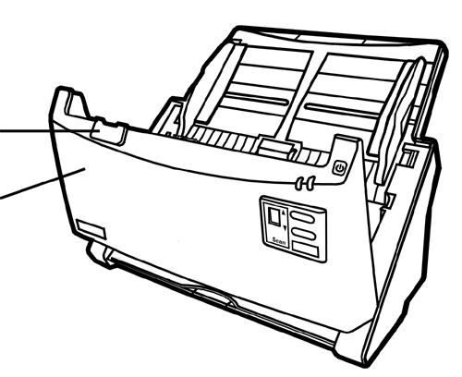
Cover open lever
ADF cover
2. Gently wipe the following areas with the cloth dampened with the cleaner. Be careful NOT to scratch their surfaces.

Clean Feed Roller:
Wipe the Feed Roller from side to side and then rotate it. Repeat this until its entire surface is cleaned.

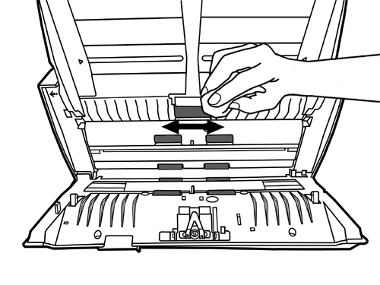

Clean Pad Module:
Wipe the Pad Module from top to bottom (in the direction of arrow shown in below picture). Be careful not to damage the pick springs of the pad.

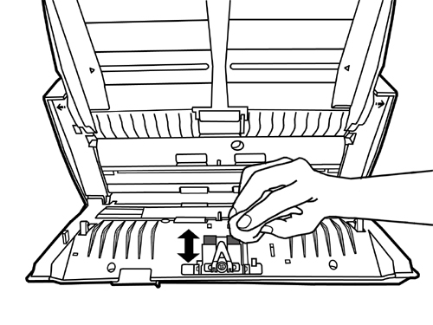

Clean ADF Glass:

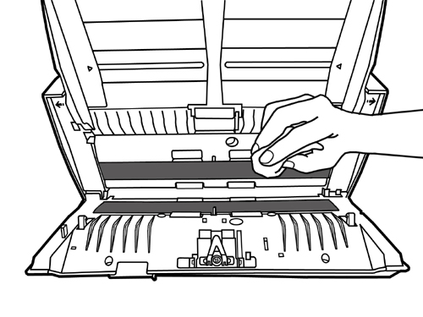
Attention | Do not spray cleaner directly onto the scanner glass. Excess liquid residue may fog the glass or damage the scanner.

3. Wait for cleaned areas to dry completely.
4. Close the ADF cover by pushing it back down until it snaps back into place.

Replacing Consumables
As a guideline, it is recommended to replace the pad module every 50,000 scans (letter-sized, 70 g/m2 or 18 lb. weight), and it is recommended to replace the feed roller every 300,000 scans (letter-sized, 70 g/m2 or 18 lb. weight).
Keeping track of how many scans you've made is easy. The Counter Utility program automatically counts the number of sheets scanned by your scanner and how many times the consumables are used. From the Windows START menu, point to All Programs > Ambir ImageScan Pro 940u, and then click Counter Utility. Refer to the online help of Counter Utility to explorer more about Counter Utility.

Replacing the Pad Module
- Open the ADF cover by pulling the cover open lever.
Cover open lever
ADF cover
- Remove the pad module by pinching both sides of the pad module and pull it out.
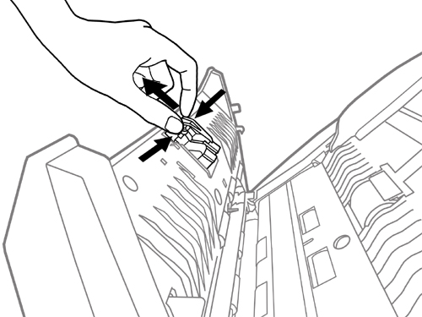

- Install the new pad module by inserting the tabs on the module onto their slots on the scanner.
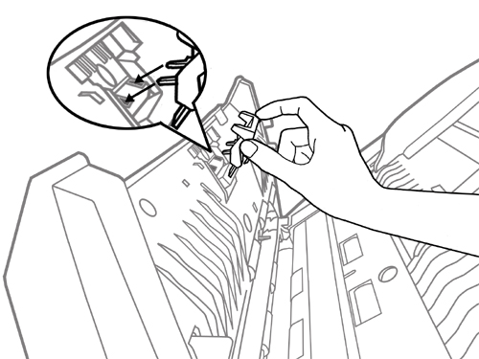
- Close the ADF cover by pushing it back down until it snaps back into place.

Replacing the Feed Roller
- Open the ADF cover by pulling the cover open lever.
Cover open lever
ADF cover

- Remove the paper chute by pinching both sides of the handles on the paper chute to remove it.
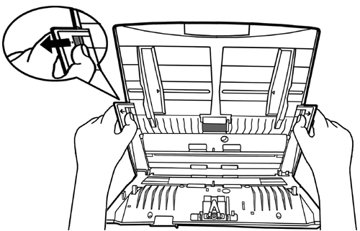
- Remove the feed roller by pinching both sides of the feed roller and pull it out.
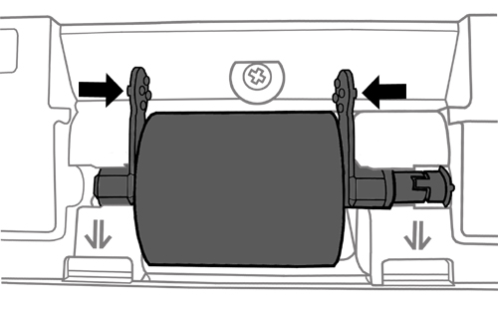
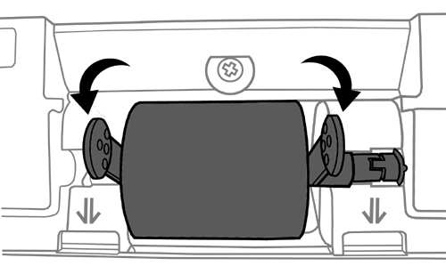
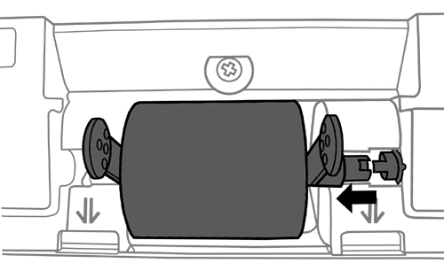
- Install the new feed roller by aligning and inserting the feed roller onto the roller assembly on the scanner.
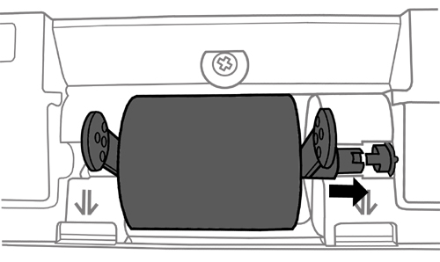
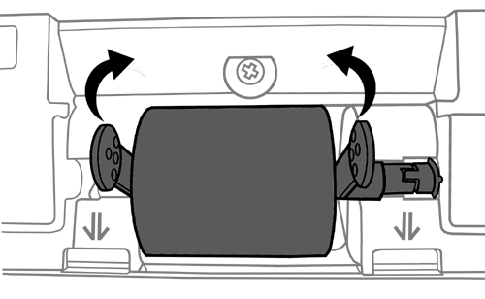
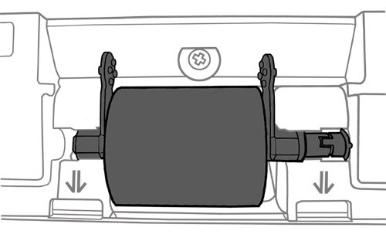

5. Install the paper chute by aligning and inserting the tabs of the paper chute into their slots on the scanner.
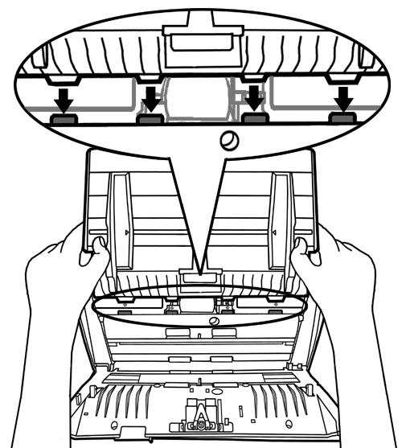
6. Close the ADF cover by pushing it back down until it snaps back into place.

Calibrating the Scanner
Calibrate the scanner if colors appear in areas that should be white, or if colors of the scanned image and of the original vary a lot. Calibration allows you to adjust and compensate for variations that can occur in the optical component over time.
The following describes how to calibrate the scanner:
- Your scanner came packaged with a special sheet with symbols printed on it called a Calibration Sheet. The Calibration Sheet is marked with an arrow on either edge at both sides and is used specifically for Ambir ImageScan Pro 940u calibration.
- Insert the special Calibration Sheet into the ADF of the scanner, with an arrow pointing toward the scanner's front buttons.
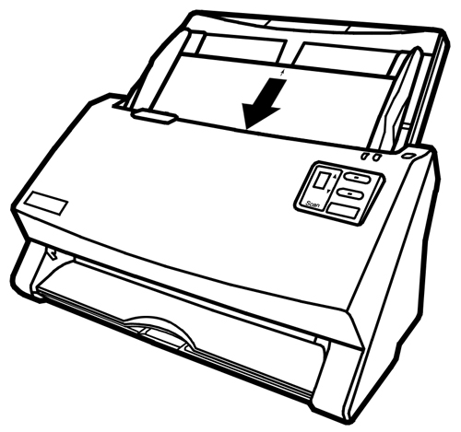
Attention | Please insert the special calibration sheet included with the scanner. As an option, you may also use any plain white sheet of letter (8.5” x 11”) -sized paper instead; however, the calibration effect may not be as precise as when the special calibration sheet is used.
- Click Start > All Programs > Ambir ImageScan Pro 940u > Calibration Wizard.
- Click Next from the Calibration Wizard that pops up and then click Calibrate Now....
- Click on the Start button to begin the calibration process.
- The scanner pulls the calibration sheet through the scanner, which completes this scanner calibration. After the calibration is complete, click OK and then click Finish.
The calibration is now done. The scanner should now show improved scanning accuracy in color and position on future scans.

Power Save
To save power consumption, the scanner light source always automatically turns itself off after the scanning process is finished. If the scanner will not be used for a long period of time, you should shut down the scanner and then disconnect the power cable from the power outlet. Leaving the power cable plugged in to a power outlet will consume electricity even if you do not operate the scanner.

Information | - The scanner will enter the standby mode (sleep mode) after it is idle for 10 minutes. Simply press any scanner button on the scanner panel and the scanner will return back to the normal status.  - From the Windows START menu, point to All Programs > Ambir ImageScan Pro 940u, and then click Scanner Utility. Refer to the online help of Scanner Utility to explore more about standby mode.

Chapter IV. Troubleshooting
If you encounter problems with your scanner, please review the installation and scanning instructions contained in this guide.
Many common use issues can be resolved by referring to the information in this chapter, or by consulting the FAQ (Frequently Asked Questions). To read the FAQ, from the Windows START menu, point to All Programs > Ambir ImageScan Pro 940u, and then click FAQ.

Scanner Connection
The first step to take when troubleshooting connection problems with your scanner is to check all physical connections, including power cable and any USB cabling and connections. The icon located on the Windows system tray, indicates if the scanner software is properly launched and the scanner and computer are communicating with each other.

Appearance | Status
 | The program has been successfully launched and the scanner is connected with the computer, ready to scan images.
 | Either the scanner is not connected with the computer or the scanner power is not switched on.
No Display | The AmbirScan ADF application is closed. The scanner may or may not be connected to the computer.

Clearing Paper Jams
If a paper jam in the ADF happens, please perform the following steps:
1. Remove any unjammed documents still loaded into the ADF.
2. Open the ADF cover by pulling the cover open lever.
Cover open lever
ADF cover
3. Gently but firmly pull the jammed documents out of the ADF. Try to avoid creasing or wrinkling the documents.
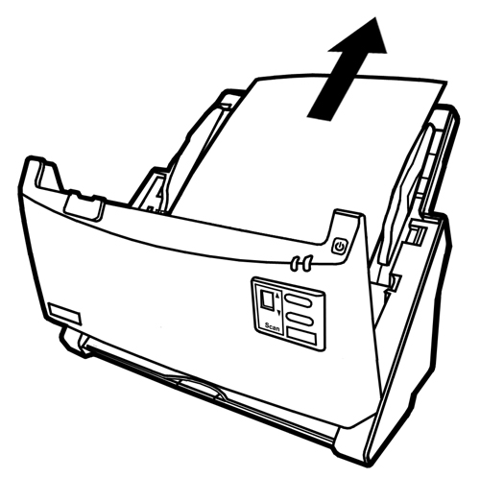
Attention | Do not try to pull jammed or half-scanned documents out of the ADF without first opening the ADF cover. Doing so may permanently damage the ADF.
4. Close the ADF cover by pushing it back down until it snaps back into place.

Appendix A: Specifications

Ambir ImageScan Pro™ 930u
Optical Resolution | 600 dpi
Max. Hardware Resolution | 600 x 600 dpi
Scan Modes | Color: Input 48-bit; Output 24-bit  Grayscale: Input 16-bit; Output 8-bit  Black & White: 1-bit
Technology | CCD Sensor
ADF Capacity | 1. 100 sheets (A4/Letter, 70 g/m² or 18 lb.)  2. 30 Business Cards  3. 5 Plastic Cards  4. Plastic Card, maximum thickness under 1.2 mm.  Note: Maximum ADF capacity varies, depending upon paper weight.
ADF Scanning Speed | 30 ppm/60 ipm (200 dpi, Color mode, Letter-sized Portrait)  40 ppm/80 ipm (300 dpi, Grayscale mode, Letter Portrait)  40 ppm/80 ipm (300 dpi, Black & White mode, Letter Portrait)  Note: Results may vary depending upon your scanning application, computer processor and system memory.
Scan Area  (W x L) | Maximum 216 x 356 mm (or 8.5” x 14”)  Minimum 13.2 x 13.2 mm (or 0.52” x 0.52”)
Acceptable Paper Sizes (W x L) | Maximum 244 x 356 mm (or 9.6” x 14”)  Minimum 50.8 x 50.8 mm (or 2” x 2”)
Acceptable Paper Weight for ADF | 50 to 105 g/m² (or 14 to 28 lb.)
Power Adapter | DC 24V, 1.25 A
Power Consumption | Operation: | < 24 W
 | Idle: | < 4.5 W
 | Standby (sleep mode): | < 0.5 W
 | Off Mode: | < 0.3 W
Interface | USB 2.0 High Speed
Operating Temperature | 5°C to 40°C (41°F to 104°F)
Relative Humidity | 20% to 80% (non-condensing)
Physical Dimensions (WxDxH) | 318.7 x 230.7 x 228.3 mm (12.55" x 9.08" x 8.99")
Weight | 2.7 Kgs (5.95 lb.)
Protocols | TWAIN Compliant
EMI | FCC Class B, CE

Appendix B:
Customer Service and Warranty
Free Technical Support Through Email & Web
Visit Ambir’s website at http://www.ambir.com for online access to technical support information including: installation guides, FAQs, troubleshooting tips, and driver downloads. Contact email addresses and a chat feature are also available online for your convenience in reaching us should you need further assistance.
To avoid delays, please have the following information available before calling:
  - Scanner name and model number
  - Scanner serial number (Located at the rear of the scanner)
  - Scanner CD version and part number
  - A detailed description of the problem
  - Your current operating system
  - Name of software package(s), version or release number and manufacturer of the software
  - Other USB devices installed

Technical Support by Telephone
Support is available from 7:00 a.m. – 7:00 p.m. Central Time Monday-Friday by dialing (630) 530-5400 or (800) 915-9930, option 3. For all Ambir scanners you can speak directly to a technical support representative or leave a message for a call back. You will be connected to a highly trained, friendly and professional support agent who will work with you to resolve your issue. For expediency when you call please be in front of your system with your software and documentation handy for troubleshooting.
*We will make every effort to respond to telephone support calls within one (1) business day. However, we strongly suggest that you make initial contact via email with an explanation of the problem you are experiencing and a call-back number should we need to speak to you directly.

Product Warranty Information
Statement of Limited Warranty for the United States, Canada and European Economic Community:

Products – Ambir ImageScan Pro™ 940u
Warranty Period – 1 year
*Contact your place of purchase for warranty service information

Warranty for Products
Ambir Technology warrants our products against defects in materials and workmanship to the original purchaser for a period of one (1) year from the date of the original purchase. This warranty is limited to repair or replacement of the product, and the remedy provided to the purchaser for warranty service is the sole discretion of Ambir Technology.

Extent of Warranty
Any use of the product for a purpose in which it is not intended, and/or purchaser modifications, alterations, and/or repairs to the product, will constitute misuse and are not subject to the warranty. The warranty does not cover the repair or exchange of a product resulting from accident, unsuitable physical or operating environment, or failure caused by a product for which the Ambir is not responsible.

Items Not Covered by the Warranty
Host computer operating systems, application programs or hardware configurations are not covered.

For customer service or further warranty information please email or call Ambir directly. Please provide product model name and number, place and date of purchase, your name, daytime telephone number and a description of the difficulty you are experiencing. You will normally receive a written email response or call-back within one (1) business day.

Ambir Technology
918 N. Oak Lawn Ave.
Elmhurst, IL 60126 USA
Toll Free: (800) 915-9930
Main Number: (630) 530-5400
Technical Support: (630) 530-5400 option 3
www.ambir.com

FCC Radio Frequency Statement
This equipment has been tested and found to comply with the limits for a Class B digital device, pursuant to part 15 of the FCC rules. These limits are designed to provide reasonable protection against harmful interference in a residential installation.
This equipment generates, uses and can radiate radio frequency energy and, if not installed and used in accordance with the instructions, may cause harmful interference to radio communications. However, there is no guarantee that interference will not occur in a particular television reception (which can be determined by turning the equipment off and on), the user is encouraged to try to correct the interference by one or more of the following measures:
- Reorient or relocate the receiving antenna.
- Increase the separation between the equipment and receiver.
- Connect the equipment to an outlet on a circuit different from that which the receiver is connected.
- Shielded interconnect cables and shielded power cord which are supplied with this equipment must be employed with this equipment to ensure compliance with the pertinent RF emission limits governing this device.
- Consult the dealer or an experienced radio/TV technician for help if the conditions persist.
Changes or modifications not expressly approved by the manufacturer or authorized service center could void the user’s authority to operate this equipment.
This device complies with Part 15 of the FCC Rules. Operation is subject to the following two conditions: (1) this device may not cause harmful interference, and (2) this device must accept any interference received, including interference that may cause undesired operation.

Higher requirements may be needed when scanning or editing large quantities of images. The system requirements stated are only a guideline. Generally, the better the computer (motherboard, processor, hard disk, RAM, video graphic card), the better the results.
Save the box and packing materials in case you need to transport this scanner in the future.
The USB hub is not included with the scanner.
Hardware specifications may change at any time without prior notice.

